
Note to Reader:
This document may be used by Customers as a substitute for their questionnaires / surveys to approve AJW Group as a supplier.
This pack is updated at least once a year and therefore the information contained herein is correct as of the review date of February 2026.
Quality Exposition & Self-Audit

Table of Contents
1 Company Details 4
1.1 Overview 4
1.2 Registered Address 4
1.3 Additional Sites 4
1.4 Quality Approvals 5
1.5 Approvals Held 5
1.5.1 AJW Aviation 5
1.5.2 Other Locations 5
2 Contacts 5
2.1 Company Contact Details 5
2.2 Board Director 6
3 Facilities 6
3.1 Facilities Size 6
3.2 Staff Levels 6
4 Capability 6
4.1 Type of Business 6
4.2 Services Provided 6
4.3 Product Lines 6
4.4 Main Customers 7
4.5 Key Partners 7
4.6 Key Vendors 7
5 Financials 7
5.1 Revenue 7
5.2 Trade References 7
6 Quality Management System Information 8
6.1 Organisation Chart 8
6.2 Internal Audit Programme 8
6.3 External Audit Programme 8
6.4 Evaluation Questionnaire 9
Appendix 1 - Sample Documents 15
ATA Spec 106 Material Certification Form 15
Product Specification Certificate 16
ISO 9001:2015 and AS9120B Certificate 17
ISO 14001:2015 Certificate 18
ASA-100 and FAA Advisory Circular 00-56B Certificate 19
Civil Aviation Authority of Nepal Certificate 20

Company Details

Overview
Company Name | A J Walter Aviation Limited
Trading Name | AJW Aviation/AJW group
Group Companies | AJW Technique
 | AJW Technique Europe
 | AJW Leasing
 | AJW Capital
Company Registration No. | 699050
Registered Date | 21st July 1961
SITA | LGWJWCR
CAGE Code | KB335
Dun & Bradstreet No. | 217219161
CAA Known Consignor UAI | GB/KC/01379-01
Year of Establishment  VAT Number | 1932  GB717870119
Type of Ownership | Limited Company (Private)

Registered Address
The Headquarters
Maydwell Avenue
Slinfold
West Sussex
RH13 0AS
United Kingdom

Additional Sites
AJW Aviation Singapore PTE LTD  9 Tan Quee Lan Street  Singapore  188098 | A J Walter China  1225, 12th Floor, West Nanjing Road  Jing’an District  200041, Shanghai,  China
AJW Türkiye  Hürriyet Bulvari  SkyportResidence No: 1/184  Beylikdüzü/Istanbul  Türkiye | AJW Mexico  Andres Bello 45-Piso 18  Colonia Polanco  Seccion IV  Miguel Hidalgo  11550  México City  México

Quality Approvals

Approvals Held

AJW Aviation
Standard | Original Approval Date | Certificate | Expiry Date
ISO 9001:2015 | 15 Jun 2009 | AJWG-004-08-24-1 | 15 Aug 2027
ISO14001:2015  AS9120B | 08 Apr 2025  15 Jun 2009 | 253126  AJWG-004-08-24-1 | 07 Apr 2028  15 Aug 2027
ASA-100 | 26 Oct 2020 | 17771020-4 | 24 Oct 2026
FAA AC00-56B | 26 Oct 2020 | 17771020-4 | 24 Oct 2026
CAA Nepal 2006 SUPP/APP/15/2006 15 Jul 2026

Other Locations
A J Walter Aviation Limited have other strategic locations worldwide as part of the AJW group that are not accredited but follow the principles of the quality management system implemented by A J Walter Aviation Limited. These locations are:
AJW Aviation Singapore PTE LTD  9 Tan Quee Lan Street  Singapore  188098 | A J Walter China  1225, 12th Floor, West Nanjing Road  Jing’an District  200041, Shanghai,  China
AJW Türkiye  Hürriyet Bulvari  SkyportResidence No: 1/184  Beylikdüzü/Istanbul  Türkiye | AJW Mexico  Andres Bello 45-Piso 18  Colonia Polanco  Seccion IV  Miguel Hidalgo  11550  México City  México

Contacts

Company Contact Details
email | enquiries@ajw-group.com | email AOG | aog@ajw-group.com
Website | http://www.ajw-group.com/ | Telephone AOG | +44 (0) 1403 798888
Telephone | +44 (0) 1403 798000 | Mobile AOG | +44 (0) 7831 583205
Fax | +44 (0) 1403 710936 | Fax AOG | +44 (0) 1403 710934

Board Director
Christopher Whiteside | Chairman

Facilities

Facilities Size
120 000 square feet.

Staff Levels
Total HQ Staff | 533
Management & Administration | 113
Premises | 21
Procurement | 18
Sales & Repairs Management | 197
Supply Chain- Logistics | 50
Supply Chain - Warehouse | 117
Technical & Compliance | 17

Capability

Type of Business
The AJW Group is the world-leading independent specialist in the supply and repair of aircraft spare parts. For further information visit www.ajw-group.com.

Services Provided
AJW specialises in the supply, exchange, repair and lease of modern commercial aircraft spare parts including services in aircraft engines, consumables, total repair process management, power-by-the-hour and pool access, logistics, engineering and aircraft project management. Supported by an infrastructure of strategic spares hubs spanning the globe, AJW's 24/7/365 AOG and critical response service is highly regarded throughout the industry.
For further information visit www.ajw-group.com.

Product Lines
AJW Group is a world-leading independent aircraft component parts, repair, and supply chain solutions provider, transforming efficiency in commercial, business, and defence aviation. AJW companies hold significant core inventories for the latest Airbus and Boeing family of aircraft, with over 450,000 line items in stock at any one time valued at over US$500m. A key part of AJW Group is AJW Technique, a 220,000 sq. ft state-of-the-art component MRO facility based in Montreal which has the expertise in maintenance and repair to offer quality-focused services to the global aviation marketplace across a diverse range of commercial and business jet platform types and the ability to process 35,000 units a year across 6,000 separate part number lines.

Main Customers
AJW Group companies provide integrated component support solutions for more than 1,000 airlines, aircraft manufacturers and component OEMs worldwide. These range from flag carriers to low-cost airlines and start-ups, and cover repair and overhaul, right through to aircraft engine management and lease options.
AJW has a global presence with operational hubs and local offices across Africa, Asia Pacific, China, CIS, Europe, Latin America, Middle East, and North America and deliver an award-winning package of global services supporting 69% of global fleet operators with appropriate Airbus and Boeing aircraft types.

Key Partners
- AJW manages ultra-low-cost carrier start-ups all the way to the biggest single fleet operator in the world, including Aer Lingus, Air Canada, Air Transat, Azerbaijan Airlines, Arajet, easyJet, Silkway West Airlines.
- Maintenance providers such as: Delta Tech Ops, British Airways Engineering, Iberia Maintenance & Engineering and GAMECO.
- OEMs such as: Thales, Honeywell, Collins Aerospace, GKN Aerospace, Safran, Liebherr, and Woodward.
- Financiers such as: Arena Investors and HSBC.

Key Vendors
AJW manages a streamlined vendor supply chain of 60 primary repair workshops with 700 approved facilities.
AJW spends US$400m annually on almost 100,000 repair orders.
Quality, reliability and delivery underpin competitive pricing from such primes as AJW Technique, Avia Technique, Fokker, Hamilton Sundstrand, Honeywell Aerospace, Liebherr, Moog, Rockwell Collins, Thales, Safran Group and Ametek Group.

Financials

Revenue
Over US$500M per annum.

Trade References
- On Request

Quality Management System Information

Organisation Chart
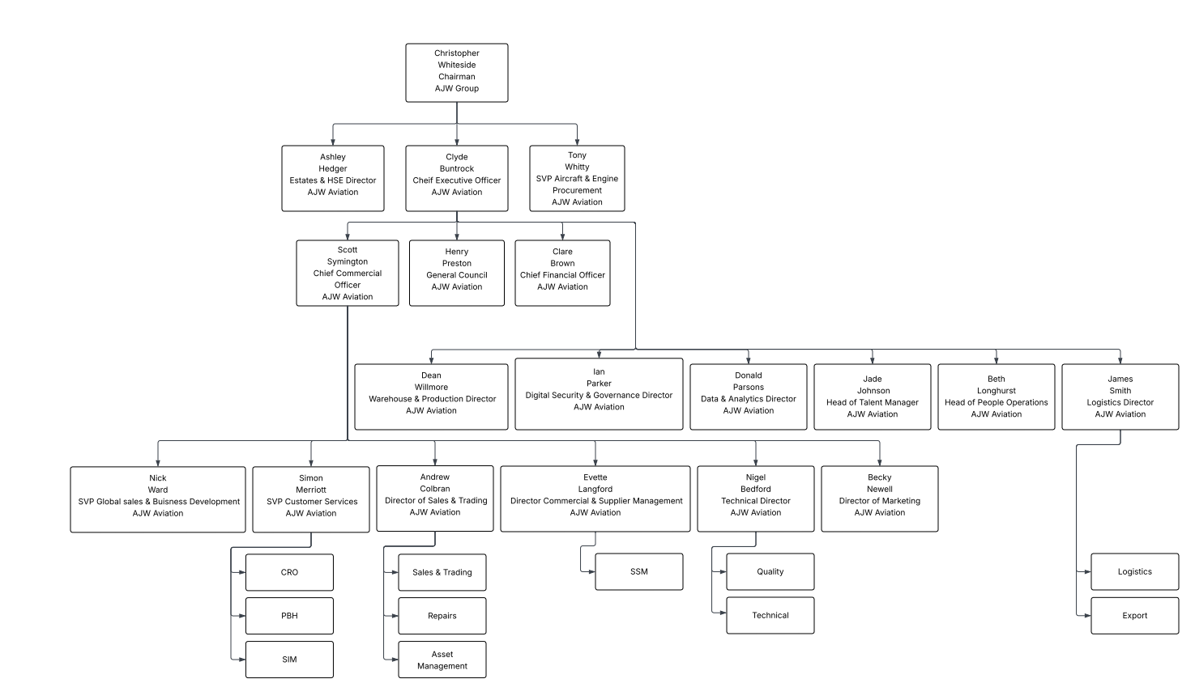
Internal Audit Programme
- On Request

External Audit Programme
Standard | Certifying Body | Last Audit Date
ISO 9001:2015 | ASACB | 11 April 2025
ISO14001:2015 |  | 25 March 2025
  BAB
AS9120 Rev B | ASACB | 11 April 2025
ASA-100 | ASA | 14 April 2024
FAA AC 00-56B | ASA | 14 April 2024

Evaluation Questionnaire
EXPLANATION: This form is prepared as part of A J Walter Aviation Limited Quality Assurance - Supplier Audit function
PART-1 GENERAL INFORMATION
COMPANY NAME | A J Walter Aviation Limited |  |  | Years in Business |  | 90+
OWNERSHIP | AJW Holdings Limited
REGISTERED ADDRESS | AJW Aviation Ltd, The Headquarters, Maydwell Avenue, Slinfold, West Sussex  RH13 0AS, United Kingdom
TELEPHONE | +44 1403 798000 |  |  | FAX: +44 1403 710936
E-MAIL | enquiries@ajw-group.com |  |  | SITA: LGWJWCR
CHAIRMAN | Christopher Whiteside
CEO | Clyde Buntrock |  |  | Email: |  | enquiries@ajw-group.com
QUALITY MANAGER | Robert Dallman |  |  | Email: |  | quality@ajw-group.com
SALES MANAGER | Tony Whitty |  |  | Email: |  | commercial@ajw-group.com
NATURE OF BUSINESS |  | OEM |  |  | PMA
NATURE OF BUSINESS |  | OEM Authorised Distributor |  |  | OTHER: _____________________________
NATURE OF BUSINESS |  | Distributor
QUALITY APPROVAL |  | ISO 9001 |  |  | ASA-100
QUALITY APPROVAL |  | AS/EN 9100 |  |  | ISO 14001
QUALITY APPROVAL |  | AS/EN 9120 |  |  | OHSAS 18001
QUALITY APPROVAL |  | FAA AC 00-56 |  |  | ISO 27001
DATE QUALITY  SYSTEM ADOPTED | 1990
CERTIFIED BY | ASACB
DATE OF LAST  RE-CERTIFICATION | 16 August 2024 |  | CERTIFICATION NO |  |  |  | AJWG-004-08-24-1
EMPLOYEES | 533 |  | TECHNICAL & COMPLIANCE |  |  |  | 17
LOGISTICS | 50 |  | WAREHOUSE |  |  |  | 117
SALES | 197 |  | ADMINISTRATION |  |  |  | 113
Number of Certifying Staff who are authorised to certify products? | Nil – AJW Aviation do not hold a Part 145 approval.  AJW are stockists and distributors and not approved to repair and certify aerospace products. We do however manage this service, by using approved repair stations to recertify products after test/inspection, repair, overhaul or modification.
COMPLETED BY  (Name & Position) | Robert Dallman – Quality Assurance Manager
Signature/Date

PART-2
2.1 QUALITY SYSTEM | YES | NO | N/A
2.1.1 Do you have established Quality System and an approved Quality Manual?
Current revision No QM1 v20 Revision Date: June 2023
2.1.2 Is your “Quality Manual” available to view?
2.1.3 Is the quality system documentation kept current and readily available to employees, customers, auditors or designee(s)?
2.1.4 Does quality system includes a program by which the accreditation organization is notified of any significant changes to the quality system and that a written approval is received for the changes prior to implementation?
2.1.5 When deficiencies are discovered, are they recorded and monitored to prevent recurrence?
2.1.6 Is the quality assurance program working to identify weaknesses and to correct them within the system?
2.1.7 Is the relevant information on corrective actions submitted for Management’s review?
2.1.8 Does the QUALITY MANUAL include detailed description of:
- The organisation and relationships of the Quality Dep. to the rest of the organisation?
- The assignment of the personnel by title, for specific functions within the quality system?
- The revision control system for the quality system documentation?
- Record keeping system?
- Training requirements and records?
- Shelf life control system?
- Control of incoming discrepant parts and supplies?
- Receiving inspection procedures?
- Test and inspection equipment calibration program?
- Purchasing process procedure?
- Record of approved sub-contractors?
- Part identification system?
- Environmental control?
- Inspection stamps control?
- A process of identifying, handling, documentation and shipping of Hazardous materials?
2.1.9 Is there an established documented self-audit/evaluation program which identifies who within the company is responsible for conducting self-audits, the frequency of audits, audit documentation and corrective action?
2.1.10 Is there written procedure for review of contracts?

2.2 FACILITIES | YES | NO | N/A
2.2.1 Do you maintain warehousing facilities for stocking and distribution of civil aeronautical parts?
- If “Yes”, state the location and address:
AJW Aviation Ltd Maydwell Avenue Slinfold
West Sussex
RH13 0AS
United Kingdom
- Area in sq. ft.: 120,000
- Aircraft type(s): Airbus, Boeing, ATR and Embraer
- Engine type(s): CF6-80; CFM56-3/5/7; V2500; RB211; PW4000
2.2.2 Do storage areas provide:
- Adequate space and appropriate racks to prevent damage or mishandling?
- Adequate security from unauthorized access?
- Segregation of aircraft from non-aircraft functions?
- Segregation of serviceable parts from non-serviceable parts?
- Adequate storage conditions for ESDS parts and DG parts and provide segregation of DG parts?
- Humidity, temperature and lighting control?
2.3 TRAINING and AUTHORISED PERSONNEL | YES | NO | N/A
2.3.1 Are personnel who perform inspection, shipping and receiving functions properly trained?
- Are inspection personnel trained for packing and handling of hazardous/dangerous and non-hazardous/dangerous products?
2.3.2 Are inspection personnel properly authorized?
2.3.3 Are both formal classroom and on-the-job training documented and maintained?
2.3.4 Is a roster of personnel authorized to perform inspection functions maintained?
2.4 PROCUREMENT | YES | NO | N/A
2.4.1 Does the system assure that parts procured conform to the documentation requirements of approval standards (FAA/ASA/EASA/CAA etc.)?
2.4.2 Does the system assure that parts conform to the customer’s purchase request and those deviations are disclosed and approved by the customer?
2.4.3 Does the system require the distributor to maintain a list of approved suppliers and a quality history for each source?
2.4.4 Are approved supplier/subcontractors monitored and audited per defined interval?
2.4.5 Does the distributor’s quality system assure that parts procured for sale:
- Which are known to have been subjected to conditions of extreme stress, heat or environment are identified?
- That all represented Airworthiness directives (AD’s) which have been accomplished are documented?
- That are identified as overhauled, repaired or modified have all the appropriately signed and dated documentation?
2.5 RECEIVING INSPECTION | YES | NO | N/A
2.5.1 Does the inspection program include:
- A check for obvious physical damage?
- Verification that all appropriate plugs and caps are properly installed?
- Verification of part number, serial number, model number, etc. to ensure they match the documentation?
- Verification of quantity, part numbers or noted substitution, to ensure they match the purchase order?
- Verification that all appropriate documentation is on hand and properly completed and signed?
2.5.2 Does the inspection system include a procedure for receiving aircraft fasteners?
2.5.3 Is there a procedure for reporting unapproved parts in accordance with FAA AC 21-
29?
2.5.4 Is there an accountability system in place to control stamp issuance, usage and replacement?
2.5.5 Does the system include an inspection program for new standard parts?
2.5.6 Are the results of inspection documented, for how long?
2.5.7 Are the inspected items properly segregated from material awaiting inspection?
2.5.8 Is the inspected material adequately identified for acceptance of rejection?
2.6 MEASURING AND TEST EQUIPMENT | YES | NO | N/A
2.6.1 Does the distributor have an effective calibration program for test equipment?
2.6.2 Is a system in place to assure documentation of current calibration status for each tool?
2.6.3 Are adequate environmental controls used for storage of measuring and test equipment?
2.7 MATERIAL CONTROL | YES | NO | N/A
2.7.1 Is material handled in an appropriate manner and is the material protected from damage & deterioration?
2.7.2 Is batch/lot control maintained for parts so identified by the manufacturer?
2.7.3 Is there a system in place for recall control which ensures that parts shipped can be traced and recalled?
2.7.4 Whenever practical, is material stored & delivered in the manufacturer’s original packaging?
- Does the system require the use of ATA specification 300 packaging, an equivalent packaging to ATA 300 or customer specified packaging?
2.7.5 Does the system specify material control requirements for material subject to damage by electrostatic discharge?
2.7.6 Does the system assure that serviceable pats/components are adequately protected against the environment?
2.7.7 Does the system assure that no part number ambiguity exists?
2.7.8 Does a closed loop system exist to implement corrective action following detection of substandard or non-conforming parts?
2.7.9 Are aircraft parts being segregated from non-aircraft parts?
2.7.10 Is there a documented procedure in place to mutilate scrapped parts?
- Does the system require records and documentation to be kept on all serialized scrapped parts?
- Does the distributor maintain records and documentation?
- Does the distributor impose their scrap requirements on their contractors?
2.7.11 Does the distributor have a system to control parts that have been materially misrepresented?
- Is the distributor notifying the customer and the accreditation organisation when the distributor ships parts that are materially misrepresented?
- Is the distributor notifying the sender when distributor receive parts that are materially misrepresented?
2.7.12 Do you have AOG desk?
2.8 SHELF-LIFE CONTROL | YES | NO | N/A
2.8.1 Does the distributor have a system for identifying and controlling shelf-life limited parts?
2.8.2 Does the system specify following material handling/ packing/preserving/control and delivery requirements:
- Rubber products?
- Composite materials?
- Chemicals and oils?
- Aircraft tyres?
- Material subject to damage by electrostatic discharge?
- Other products with shelf lives?
2.9 CERTIFICATION AND RELEASE OF MATERIAL | YES | NO | N/A
2.9.1 Does the system provide for the issuance of a certified statement disclosing that the material or parts were or were not:
- Subjected to conditions of extreme stress, heat or environment;
- Obtained from the Government or military services.
2.9.2 Is a signed document from an EASA/CAA/FAA approved repair station or air carrier provided for each serviceable part indicating the part is serviceable?
2.9.3 Can the distributor trace parts in its system to either the source of production or to a EASA/CAA/FAA certificate holder?
2.9.4 Does the quality system have a procedure for accountability when copies are made for re-distribution shipments and approval tags are copied?
2.10 SHIPPING | YES | NO | N/A
2.10.1 Does the quality system require shipments in ATA-300 containers or equivalent as appropriate for the unit being shipped, or as specified by the customer?
2.10.2 Does the quality system provide for a visual inspection of all items and accompanying documentation prior to shipping? Does the inspection include:
- A check for any obvious physical damage?
- Verification that all appropriate plugs and caps are properly installed?
- Verification of part numbers, (including dash numbers & letters), model numbers, serial numbers, etc., to ensure items being shipped match the accompanying documentation?
- Verification of part numbers, (including dash numbers & letters), model numbers, serial numbers, etc., to ensure the items being shipped match the customer's request/purchase order?
- Verification of packing slips to ensure it contains all the information required by the customer?
- Verification that shipping containers and packaging used are appropriate for the items being shipped?
- Verification that all appropriate documentation (maintenance release, material certification, traceability documents, etc.) are at hand, properly completed, and signed?
2.11 CUSTOMER SATISFACTION | YES | NO | N/A
2.11.1 Do you have a customer satisfaction analysis program?
2.11.2 Do you evaluate customer feedback and take action if necessary?
2.11.3 Does management reviews customer feedback periodically and implement changes as necessary?
2.12 RECORDS | YES | NO | N/A
2.12.1 Does the record system require record retention for at least 7 years from the date of sale to the customer?
2.12.2 Does the quality system include a system governing the storage, distribution and retrieval of documents confirming the physical and chemical properties of fasteners and raw stock materials?
2.12.3 Are records confirming fastener integrity required to be maintained for 7 years?
2.12.4 Does the system require all life-limited parts have records confirming life-limited status?
2.12.4 Are records protected against damage, alteration, deterioration and loss?
2.13 TECHNICAL DATA CONTROL | YES | NO | N/A
2.13.1 Does the quality system provide for maintaining technical data in a manner which ensures such data is up-to-date and accessible?
2.13.2 Is there a list of regulatory authority publications and standards held and maintained?
2.1.9 Is there master listing that identifies the current revision status of all controlled documents?
2.13.3 Are the above publications available for reference to concerned staff?
2.13.4 Are adequate documentation viewing and printing devices available?
General comments:

All certificates are available from https://www.ajw-group.com/quality-and-certifications/.

AJW Aviation is not a repair station therefore we do not hold any CAA/EASA/FAA approval and we do not issue any release certificate (EASA Form1/FAA8130).

The release documents provided with the parts are obtained from our approved suppliers/vendors list in compliance with the customer requirements.

In Appendix 1 are sample documents issued by AJW Aviation.

Appendix 1 - Sample Documents

ATA Spec 106 Material Certification Form
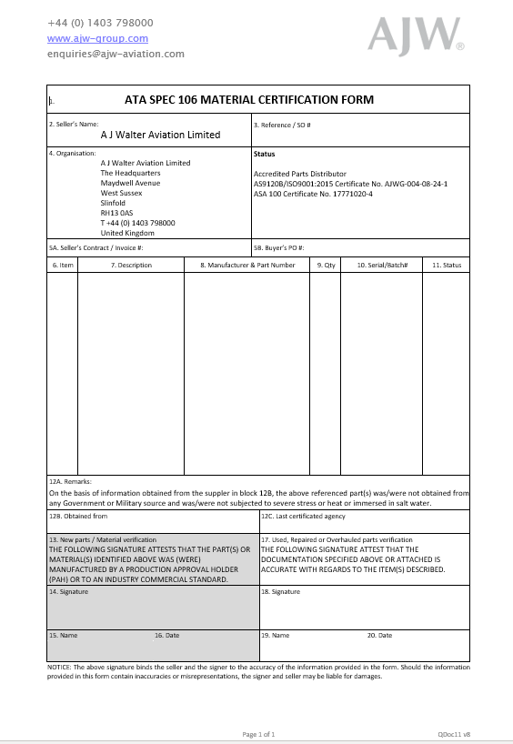

Product Specification Certificate

ISO 9001:2015 and AS9120B Certificate
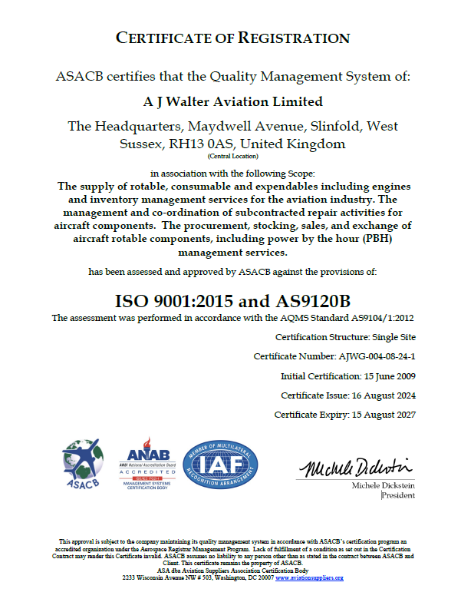

ISO 14001:2015 Certificate

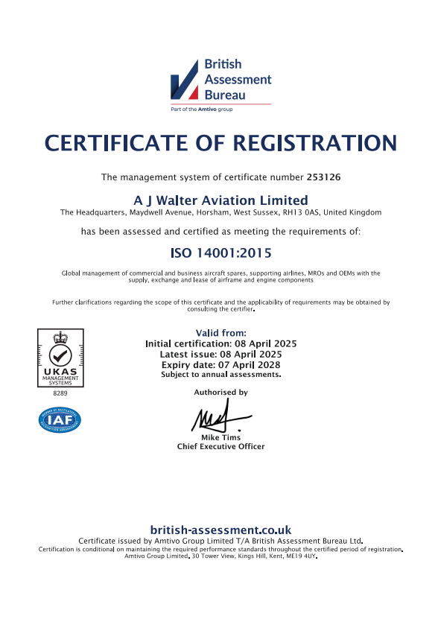

ASA-100 and FAA Advisory Circular 00-56B Certificate
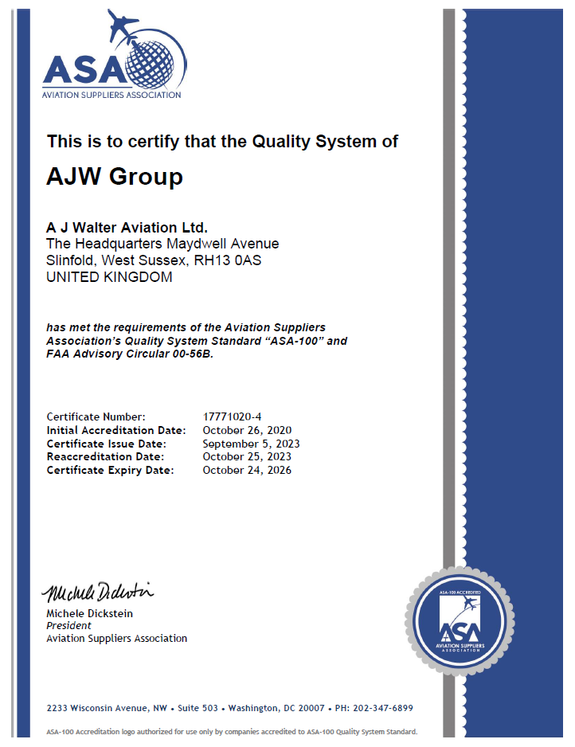

Civil Aviation Authority of Nepal Certificate
